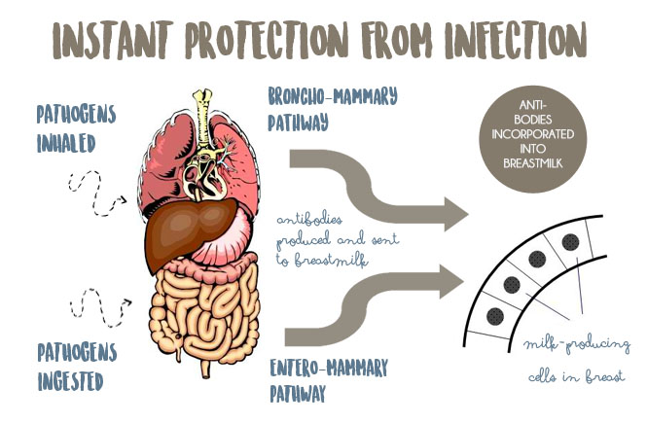
The Entero-Mammary Pathway: A Baby’s Secret Weapon
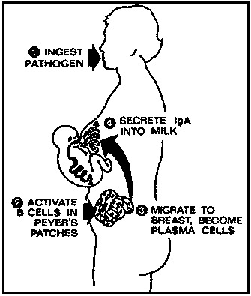
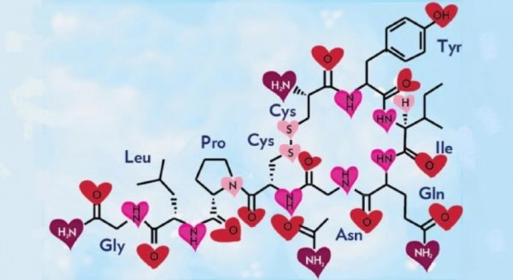
oxytocin

So, what are the benefits of high oxytocin levels, besides making you feel happy and sleepy?
- Bonding
  - Baby bonds with the mother, and is more likely to recognize her in the future.
  - Mother bonds with baby, and is more likely to interact with her or prefer her over other babies.
- Learning
  - Because oxytocin is also a neurotransmitter, it has the ability to create new pathways in the brain.
  - Oxytocin supports learning and the adapting to a new life (for both parents and baby).
- Digestion
  - High levels of oxytocin are associated with more effective digestion.
  - Babies take in more nutrition and show increased growth.
- Lower blood pressure
  - Oxytocin calms the nervous system and lowers blood pressure, resulting in relaxation in both adults and babies.
- Increased circulation
  - Blood circulates at increased rates to the skin and other parts of the body. Check out your baby’s rosy cheeks, hands, and feet. They can be evidence of high oxytocin levels.
- Feelings of calm
  - People feel satisfied, relaxed, and sometimes drowsy as oxytocin levels rise.

Benefits of Breastfeeding
